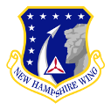
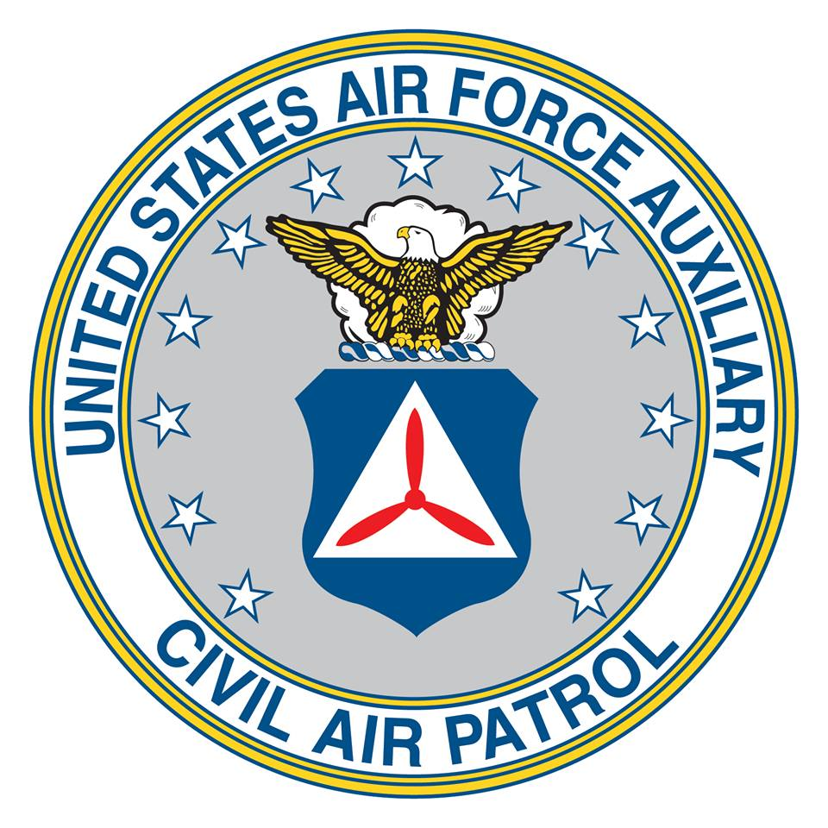
Colonel’s Leadership Initiative Scholarship

New Hampshire Wing, Civil Air Patrol

In recognition of Colonel Moran’s leadership, inspiration, and dedication to his Cadets and their life goals, we have established this monetary scholarship that can be used for any purpose with the expressed desire that it be used in a fashion that assists with those goals. For example, the funds may be used to assist with uniform costs, National Cadet Special Activities, and Encampments. Or monetary assistance with acquiring a computer for school, help to pay for tuition, or even living expenses while the recipient attends college. The amount awarded to a deserving candidate is based on need, merit, and available funds. The Wing Vice Commanders and the Chief of Staff will select the cadets and the amount of the scholarship.

Full name: ____________________________________________
Name of recipient
CAPID: _____________________
6 digit CAPID of recipient

Amount of request: _________________

Contact Information:
email address: ________________________

Phone number: ________________________

Purpose:

Authorized signature (adult parent or guardian)

Full Name of signer: __________________________________
Please print full name of signer

Signature: _________________________________ Date: ______________

Instructions:
- Print the form
- Fill in completely
- Purpose, describe the purpose of request.
- Sign. Must be signed by an adult parent or guardian.
- Scan the form and email it to: ColonelsLeadershipInitiative@nhwg.cap.gov
- If you are unable scan the form make a copy and send the original to:

New Hampshire Wing, Civil Air Patrol
51 Airport Rd
Concord, NH 03301

Att’n: Colonel’s Leadership Initiative Scholarship

